Project Report
ANALOG CALCULATOR USING LTSPICE
Name: Tirth kushwaha
Class: SE E&TC A 48

EXECUTIVE SUMMARY:
Operational amplifiers are widely used in analog electronics to perform mathematical operations on electrical signals. In this work, four fundamental op-amp circuits were designed and studied: Adder, Subtractor, Integrator, Differentiator, Log and Anti-Log. These circuits form the basis of analog computing and signal processing systems.
The circuits were implemented and analyzed using the LM741 operational amplifier and simulated in LTspice. Both DC and AC input signals were applied to observe the behavior of each configuration.
During experimentation several practical issues were encountered, including phase inversion, output saturation, incorrect feedback connections, very small output voltages, and instability in differentiator circuits. These issues were analyzed and resolved by adjusting feedback components, correcting resistor placement, and understanding the theoretical operation of op-amp circuits.
The results demonstrate how operational amplifiers can perform basic mathematical operations such as addition, subtraction, integration, and differentiation and highlight the importance of proper circuit configuration and feedback for correct operation.

INTRODUCTION:
Operational amplifiers are high-gain differential amplifiers that are widely used in analog electronics. Because of their high input impedance and high gain, they can be configured using external resistors and capacitors to perform various mathematical operations on signals.
One commonly used general-purpose operational amplifier is the LM741. Using simple feedback networks, this device can implement circuits such as:
- Summing amplifier (Adder)
- Difference amplifier (Subtractor)
- Integrator
- Differentiator
- Log
- Anti-Log
These circuits form the core of analog calculators, where electrical signals represent numerical values and mathematical operations are performed directly in hardware.
The purpose of this experiment was to design and simulate these circuits, observe their behavior for both DC and AC inputs, and understand practical issues that occur during implementation.

THEORETICAL BACKGROUND:
Operational Amplifier Basics
An operational amplifier amplifies the difference between two input terminals.
$v_{0}=A\left[v_{N}-v_{I}\right]$ , where A is the open loop gain.

With negative feedback, the op-amp forces the two inputs to nearly the same voltage. This condition is called virtual short or virtual ground.
This principle is used in all the circuits studied.

Adder (Summing Amplifier):

Circuit Operation:
The adder circuit is implemented using an inverting operational amplifier configuration. Multiple input voltages are applied to the inverting terminal through individual input resistors.
Due to the high gain of the operational amplifier and the presence of negative feedback, the inverting input behaves as a virtual ground. As a result, currents from each input resistor flow toward the summing node and combine according to Kirchhoff’s Current Law.
The operational amplifier converts this combined current into an output voltage through the feedback resistor.
Since the summing amplifier is an inverting configuration, the output of the first stage is inverted relative to the input signals. To obtain a positive summed output, an additional unity-gain inverting amplifier was added after the summing stage. This second stage reverses the polarity again, restoring the original phase.

Output Equation:
For the inverting summing amplifier:
$$V_{o1}=-\left(\frac{R_{f}}{R_{1}}V_{1} + \frac{R_{f}}{R_{2}}V_{2}\right)$$

Where:
- $R_{f}$= feedback resistor
- $R_{1},R_{2}$= input resistors
If all resistors are equal:
$$R_{f}=R_{1}=R_{2}$$
then
$$V_{o1}=-(V_{1}+V_{2})$$
The second inverting stage produces:
$$V_{out}=-V_{o1}$$
Therefore, the final output becomes:
$$V_{out}=V_{1}+V_{2}$$
Thus, the second stage restores the polarity and produces a non-inverted summed output.

DC Input Behavior:
If two DC voltages are applied:
V1 = 2 V
V2 = 3 V
First stage output:
Vo1 = −5 V
After the second inverting amplifier:
Vout = +5 V
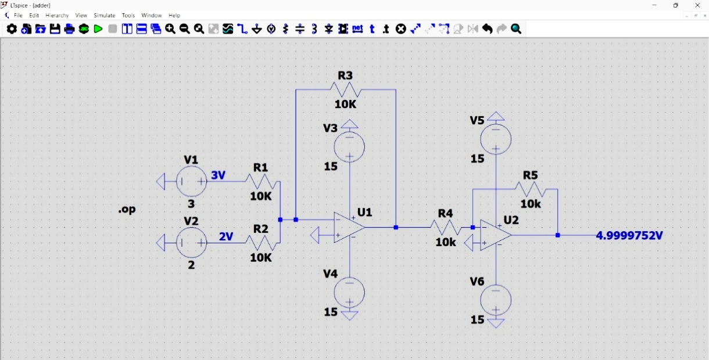
Circuit 1. Op-Amp DC Adder
Therefore, the circuit performs direct arithmetic addition of DC voltages while maintaining positive output polarity.

AC Input Behavior:
For AC input signals, the output becomes the algebraic sum of the input waveforms.
Example:
$$V_{1}=sin(ωt) \\ V_{2}=sin(ωt)$$
Resulting output:
$$V_{out}=2sin(ωt)$$

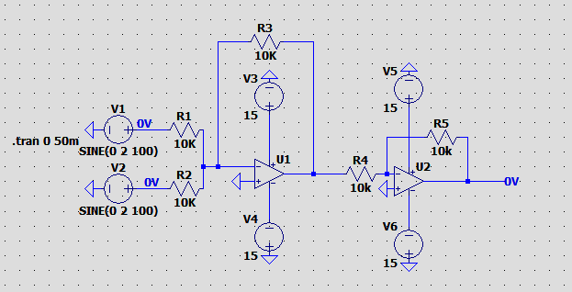
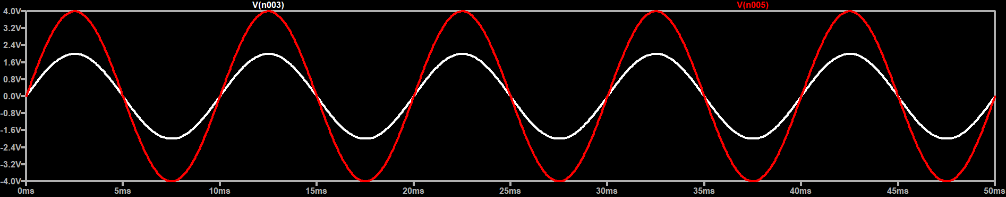
Circuit 2. Op-Amp AC Adder
Thus, the amplitude of the waveform doubles.
Because the second inverting amplifier cancels the phase inversion of the first stage, the final output waveform remains in phase with the input signals.

Observations During Simulation:
While designing and simulating the adder circuit, several practical observations were made:
- Without the feedback resistor, the operational amplifier enters open-loop operation and quickly saturates at the supply voltage.
- Equal resistor values must be used to ensure accurate summation and correct scaling of input signals.
- The first stage introduces a 180° phase inversion, which is characteristic of inverting amplifiers.
- The additional inverting amplifier stage restores the phase and produces a positive summed output.

Subtractor (Difference Amplifier):

Circuit Operation:
The subtractor circuit, also known as a difference amplifier, uses both the inverting and non-inverting inputs of the operational amplifier.
In this configuration, two input voltages are applied to the op-amp through a network of carefully matched resistors. The resistor values must maintain a specific ratio to ensure accurate subtraction of the signals.
The operational amplifier amplifies the difference between the two input voltages, producing an output proportional to the voltage difference.
The circuit relies on the principle that the op-amp attempts to keep the voltages at its two input terminals nearly equal due to negative feedback.

Output Equation:
For the difference amplifier:
$$V_{o}=\left(\frac{R_{f}}{R_{1}}\right)(V_{2}-V_{1})$$
Where:
- $R_{f}$= feedback resistor
- $R_{1}$= input resistor
- $V_{1}$= voltage applied to inverting terminal
- $V_{2}$= voltage applied to non-inverting terminal
If the resistors are matched such that:
$$R_{f}=R_{1}$$
then the output becomes:
$$V_{o}=V_{2}-V_{1}$$
Thus, the circuit produces the difference between the two input voltages.

DC Input Behavior:
If two DC voltages are applied:
V1 = 2 V
V2 = 3 V
Output:
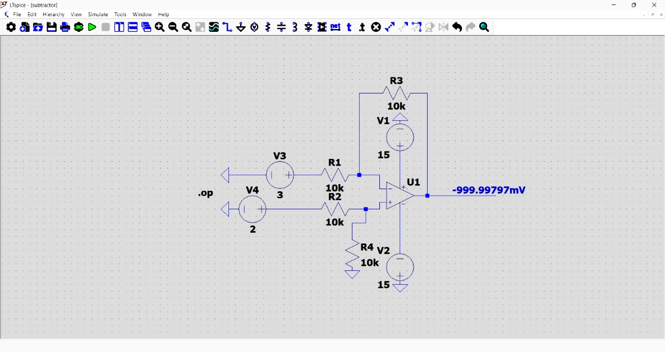
Vo = 2 V − 3 V = -1 V

This demonstrates that the circuit performs direct subtraction of DC voltages.
Such circuits are widely used in sensor measurement systems, where small voltage differences need to be amplified.
Circuit 3. Op-Amp DC Subtractor

AC Input Behavior:
For AC signals, the output represents the difference between the input waveforms.
Circuit 4. Op-Amp AC Subtractor: Verification of signal cancellation

Example:
If two sinusoidal signals are applied:
V1 = sin(ωt)
V2 = sin(ωt)

Then
Vo = 0 because both signals cancel each other.
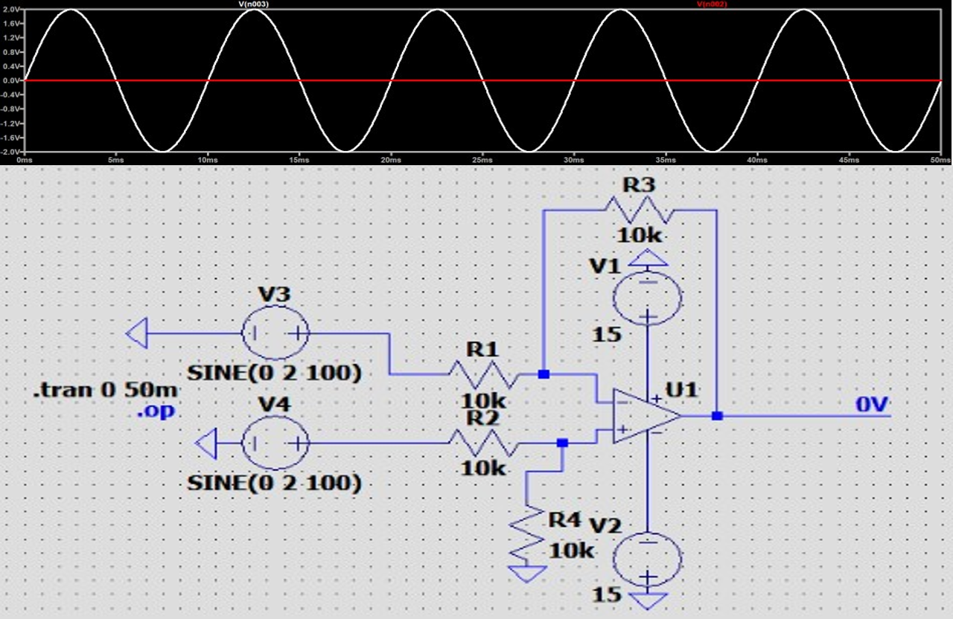
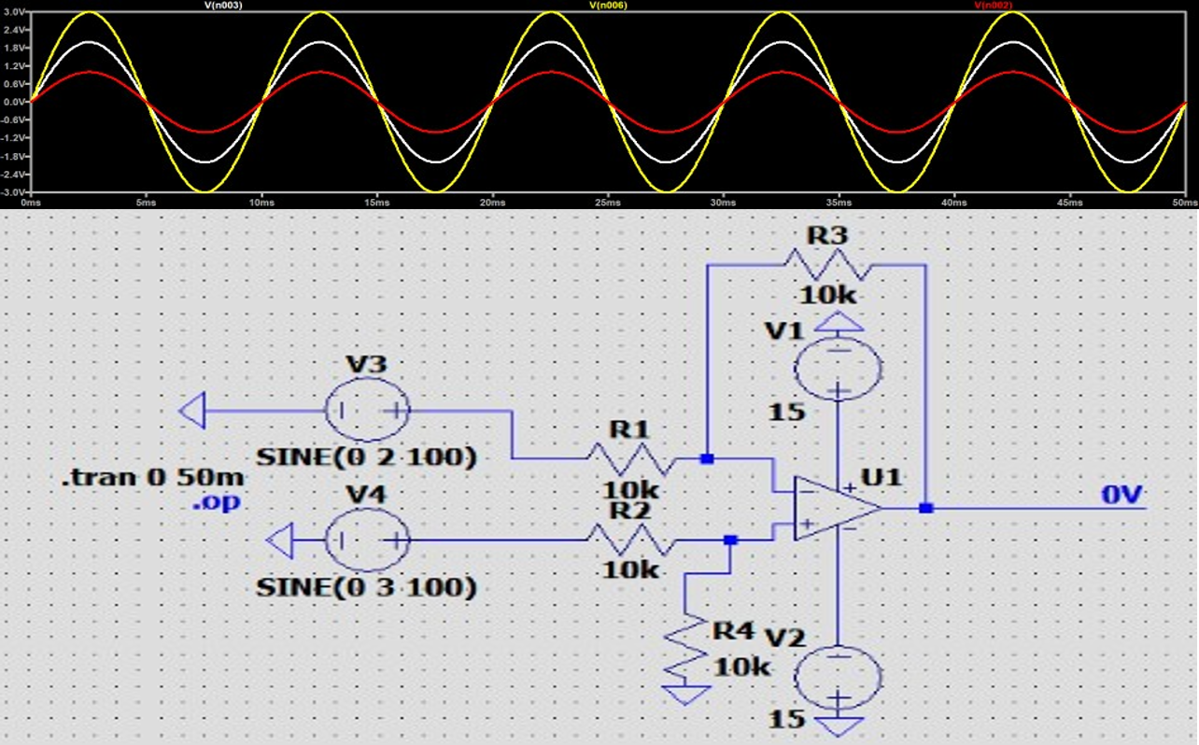
1.9
Circuit 5. Op-Amp AC Subtractor: Output waveform illustrating a differential result
.
If the amplitudes differ, the output becomes the difference waveform.

Issues Observed During Simulation:
During simulation several practical problems were encountered:
- Incorrect resistor connections caused improper subtraction and unexpected output values.
- Missing feedback resistor forced the op-amp into open-loop operation, resulting in output saturation.
- Unequal resistor values caused gain imbalance and incorrect scaling of the output signal.
- After correcting the resistor ratios and ensuring proper feedback, the subtractor produced the expected difference between the input signals.

Integrator:

Circuit Operation:
An integrator circuit is formed by replacing the feedback resistor in an inverting amplifier with a capacitor.
In this configuration, the capacitor accumulates charge over time. Because the voltage across a capacitor depends on the accumulated charge, the output voltage becomes proportional to the integral of the input signal.
The operational amplifier maintains the inverting input at virtual ground, causing current through the input resistor to flow into the capacitor.
In practical integrator circuits, a resistor is often connected in parallel with the feedback capacitor. This resistor prevents excessive accumulation of charge on the capacitor due to input offset voltages or bias currents, which would otherwise cause the output to drift and eventually saturate. The parallel resistor therefore improves circuit stability and ensures proper operation of the integrator over long periods.

Output Equation:
The mathematical expression for an integrator is:
$$V_{o}=-\frac{1}{RC}∫V_{i}dt$$

Where:
- $R$= input resistor
- $C$= feedback capacitor
- $V_{i}$= input voltage
The negative sign indicates that the circuit behaves as an inverting integrator.

DC Input Behavior (Pulsating DC):
If a constant DC voltage is applied:
Vin = Periodic
The output voltage changes linearly with time, producing a ramp waveform.
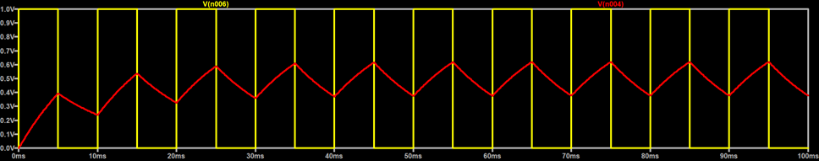
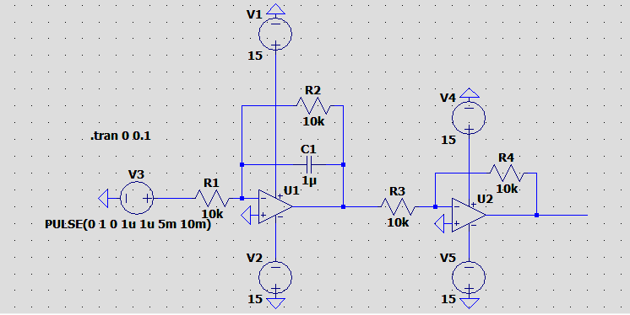
Circuit 6. Practical Op-Amp DC Integrator

This occurs because the capacitor accumulates charge only when the digital pulse is "High" (1V), forcing the output to ramp toward a target voltage. However, because of the feedback resistor (R₂), the capacitor also simultaneously discharges; when the input pulse drops to 0V, this discharge becomes dominant, causing the output voltage to ramp back down toward zero rather than holding its level.
In a practical circuit, the output waveform stabilizes into this triangular "sawtooth" pattern once the charging and discharging rates reach an equilibrium. While the operational amplifier would eventually reach its supply voltage limits and saturate if the input remained high, the pulsing nature of your signal combined with the reset path provided by the feedback resistor prevents the output from increasing indefinitely and keeps it within a functional range.

AC Input Behavior:
In the simulation, an AC sinusoidal input signal was applied to the integrator circuit using the source:
SINE (0 2 100)
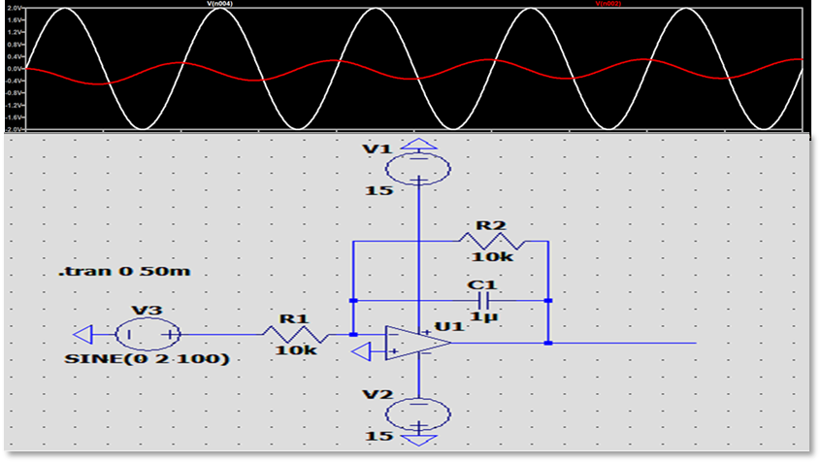
Circuit 7. Practical Op-Amp AC Integrator

This represents a sinusoidal signal with 0 V offset, 2 V amplitude, and 100 Hz frequency.
From the graph, the input signal is a sinusoidal waveform, while the output signal appears as a phase shifted waveform with smaller amplitude.

This occurs because the integrator performs the mathematical operation:
$$V_{o}=-\frac{1}{RC}∫V_{i}dt$$
For a sinusoidal input:
$$V_{i}=Asin⁡(ωt)$$
the output becomes:
$$V_{o}=-\frac{A}{ωRC}cos⁡(ωt)$$
Thus, the integrator converts the sine input into a cosine output, introducing a 90° phase shift. The negative sign indicates that the circuit operates in an inverting configuration.
The resistor $R=10kΩ$and capacitor $C=1μF$determine the rate of integration and the resulting output magnitude.

This behavior confirms the theoretical operation of the integrator, where the output represents the time integral of the applied AC input signal.

Observations During Simulation:
Several important behaviors were observed during simulation:
- When a DC input was applied, the output increased gradually until reaching op-amp saturation.
- The slope of the ramp waveform depended on the RC time constant.
- For sinusoidal input signals, the output waveform appeared as a cosine signal with phase shift relative to the input.
- These results confirm the theoretical Behavior of the integrator circuit

Differentiator:

Circuit Operation:
A differentiator circuit performs the opposite mathematical operation of the integrator.
In this configuration, a capacitor is placed at the input while a resistor is placed in the feedback path.
The capacitor allows current to flow only when the input voltage changes. Therefore, the output voltage becomes proportional to the rate of change of the input signal.

Output Equation:
The output voltage is given by:
$$V_{o}=-RC\frac{dV_{i}}{dt}$$

Where:
- $R$= feedback resistor
- $C$= input capacitor
The output depends on the derivative of the input voltage.

DC Input Behavior:
For a constant DC input:
Vin = constant
Since the rate of change of a constant signal is zero:
dV/dt = 0
Therefore, the output becomes:
Vo = 0

AC Input Behavior:
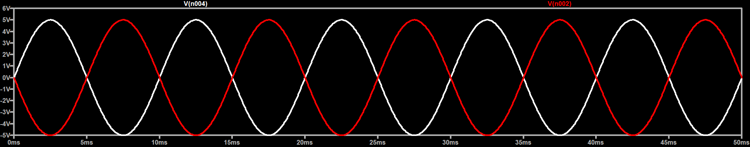
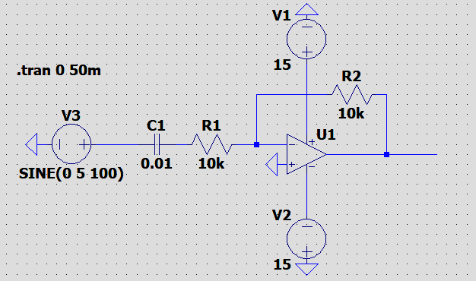
The differentiator responds strongly to rapid changes in input signals.
Circuit 8. Practical Op-Amp AC Differentiator

The output waveform corresponds to the derivative of the input waveform.

Observations During Simulation:
During simulation the following behaviors were observed:
- The differentiator amplified high-frequency components of the signal.
- Even small variations in the input produced large output spikes.
- At higher frequencies the circuit became unstable due to excessive amplification of noise.
This behavior occurs because differentiation increases the magnitude of high-frequency signals.

Logarithmic Amplifier:

Circuit Operation:
A log amplifier produces an output voltage proportional to the natural logarithm of the input voltage. In this configuration, a transistor (connected in its diode configuration, i.e., base shorted to collector) is placed in the feedback path of the op-amp, while the input signal is applied through a resistor. The transistor's inherent exponential relationship between its base-emitter voltage and collector current is exploited to achieve the logarithmic function.

Output Equation:
The output voltage is given by:
$$V_{o}=-V_{T}⋅\ln\left(\frac{V_{in}}{I_{s}⋅R}\right)$$

Where:
- $V_{T}$ = thermal voltage ($≈$ 26 mV at room temperature)
- $I_{s}$ = reverse saturation current of the transistor
- $R$ = input resistor
The output depends on the natural logarithm of the input voltage.

DC Input Behavior:

For a constant positive DC input ($V_{in}$= constant):
The transistor in the feedback path conducts and settles at a fixed operating point.
The output is a steady negative DC voltage proportional to $\ln\left(V_{in}\right)$.
The input must always be positive ($V_{in}>0$), since the logarithm of a negative or zero value is undefined.

AC Input Behavior:

The log amplifier compresses large input signals into smaller output signals.
It is particularly useful for signals with a very wide dynamic range.
Commonly used in signal processing, audio compression, and instrumentation.

Observations During Simulation:
During simulation the following behaviors were observed:
- The log amplifier compressed the dynamic range of the input signal, mapping large variations in input to smaller changes in output.
- The circuit was highly sensitive to temperature variations, causing the output to shift as the thermal voltage and saturation current changed.
- The circuit only responded to unipolar (positive) inputs, with the output saturating or becoming unstable if the input polarity was reversed. This behavior occurs because the logarithmic function scales down large values significantly while expanding differences in very small values.

Anti-Log Amplifier (Exponential Amplifier):
Circuit Operation:
An anti-log amplifier performs the exact inverse operation of the log amplifier it produces an output proportional to the exponential (anti-logarithm) of the input voltage. In this configuration, the transistor (connected in its diode configuration) is placed at the input side of the op-amp, while the resistor is placed in the feedback path. This is a direct swap of component positions compared to the log amplifier.

Output Equation:
The output voltage is given by:
$$V_{o}=-I_{s}⋅R_{f}⋅e^{\left(\frac{V_{in}}{V_{T}}\right)}$$
Where:
- $I_{s}$= reverse saturation current of the transistor
- $R_{f}$= feedback resistor
- $V_{T}$= thermal voltage ($≈$26 mV at room temperature)
The output depends on the exponential of the input voltage.

DC Input Behavior:
For a constant DC input ($V_{in}$= constant):
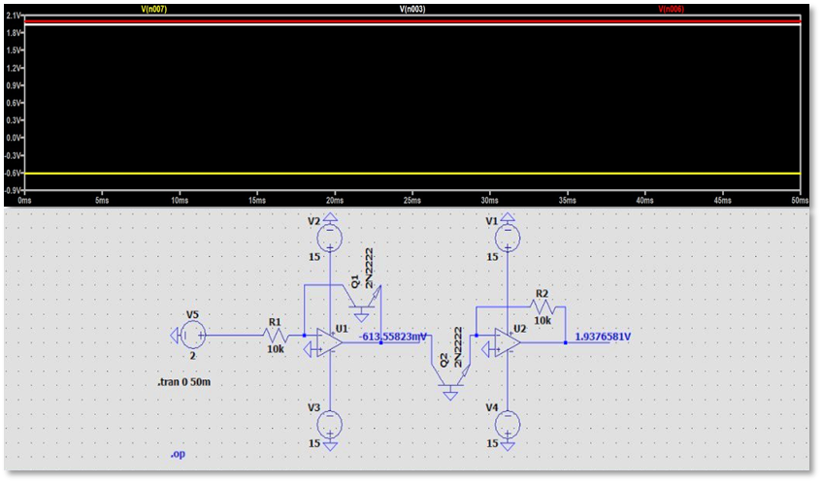
The transistor at the input is forward-biased at a fixed point.
The output is a steady DC voltage that rises exponentially with$V_{in}$.
Even small changes in input produce large changes in output due to the exponential relationship.

AC Input Behavior:
The anti-log amplifier expands small input signals into larger output signals, acting as the functional inverse of the log amplifier.
Observations: When a log amplifier and an anti-log amplifier are cascaded, they form the basis for complex analog computations such as multiplication, division, and power computation.

Observations During Simulation:
During simulation the following behaviors were observed:
- The anti-log amplifier expanded small variations in the input signal into very large output changes.
- The circuit was highly sensitive to temperature changes, causing the output to drift significantly if the thermal voltage was not compensated.
- Small increases in input voltage quickly led to the op-amp reaching its saturation limits due to the steepness of the exponential relationship. This behavior occurs because the exponential function grows at an increasing rate, making the circuit act as a high-gain expander for small signals.

KEY CHALLENGES FACED:

Challenges Faced:
During design and simulation several issues were encountered:
- Phase inversion:
Inverting op-amp configurations produced 180° phase shift.
- Output saturation:
Integrator output kept increasing until it reached the supply voltage limit.
- Incorrect feedback connections:
Without feedback resistor the op-amp operated in open loop, causing saturation.

- Very small output voltages:
In some circuits the output was only millivolts due to improper gain scaling.
- Noise amplification in differentiator:
Differentiators amplify high-frequency noise.

Solutions Implemented:
The following corrections were applied:
- Proper feedback resistors were added.
- Resistor values were matched to maintain correct gain.
- Input signal amplitude was reduced to avoid saturation.
- RC values were adjusted to control integrator slope.
- Additional resistors were used to stabilize differentiator circuits.
After these changes the circuits produced expected behavior.

Comparison of the Six Circuits:
Circuit | Mathematical Operation | Phase Relationship | DC Input Response | AC Input Response | Key Component
Adder | $$V_{1}+V_{2}$$ | 180° inversion | Output equals sum | Waveforms added | Resistors
Subtractor | $$V_{2}-V_{1}$$ | Depends on configuration | Produces difference | Cancels common signals | Matched resistors
Integrator | $$\int{V_{in}dt}$$ | −90° phase shift | Ramp output | Sine → Cosine | Capacitor in feedback
Differentiator | $$dV_{in}/dt$$ | +90° phase shift | Output ≈ 0 | Sine → Cosine derivative | Capacitor at input
Log Amplifier | $$\ln\left(V_{in}\right)$$ | 180° inversion | Steady DC $∝\ln\left(V_{in}\right)$ | Compresses dynamic range | Transistor in feedback
Anti-Log Amp | $$e^{V_{in}}$$ | 180° inversion | Steady DC $∝e^{V_{in}}$ | Expands small signals | Transistor at input
Table 1. Comparison of Op-Amp Mathematical Circuits

WORKING OF THE FINAL CIRCUIT

System Inputs (The Operands):

The circuit utilizes two independent DC voltage sources on the far left, designated as INPUT1 (connected to node A) and INPUT2 (connected to node B).

These sources represent the base numerical values for the calculation. Currently, INPUT1 is set to 2V (representing the number 2) and INPUT2 is set to 3V (representing the number 3).

These input signals are fed simultaneously into all six parallel mathematical processing blocks. To change the operands, the DC voltage values of these sources are modified directly.

Mathematical Processing Blocks:

The core calculation is performed by six distinct subcircuit blocks: ADDER, SUBTRACTOR, INTEGRATOR, DIFFERENTIATOR, LOG, and LOG-ANTILOG.

These blocks utilize operational amplifier (op-amp) configurations to perform continuous analog computations.

Because they are wired in parallel to INPUT1 and INPUT2, all six blocks compute their respective mathematical functions simultaneously.

Operation Selection Mechanism (The "Knob"):

To isolate a single mathematical result, the circuit uses a multiplexing routing system consisting of a selector source and an array of voltage-controlled switches (S1 through S6).

The SELECTOR is a separate DC voltage source configured to output a 5V control signal.

By changing the target node label on the SELECTOR source, a specific switch is closed. In the current schematic, the SELECTOR is routing 5V to the ANTI node.

This signal specifically triggers switch S6, allowing only the computed output from the LOG-ANTILOG block to pass through, while all other switches remain open and block their respective signals.

Power Supply Configuration:

The active op-amp components inside the mathematical blocks require external power to function and output a voltage. This is provided by a dual-polarity power supply at the bottom of the schematic.

VIN1 provides +15 Volts to the global node labeled V+.

VIN2 is inverted to provide -15 Volts to the global node labeled V-.

These global node labels (V+ and V-) distribute the necessary operating power to all internal op-amps without requiring visible connecting wires across the schematic.

Output Measurement and Display:

All outputs from the switch array converge at a single terminal on the far right labeled RESULT.

To view the final calculation, a transient simulation is executed using the .tran 10m command (running the circuit for 10 milliseconds).

The computed voltage is then measured by probing the RESULT node, with the software's waveform viewer acting as the visual display for the analog output.
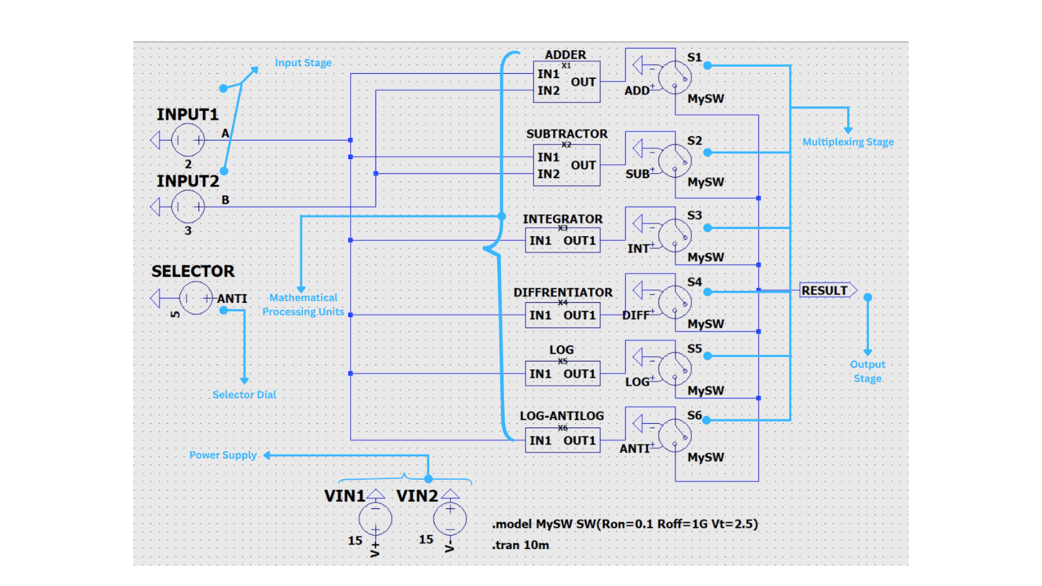
Circuit 10. Practical Op-Amp DC Input: 6 Function Calculator

CONCLUSION:
Operational amplifier circuits are highly capable of performing mathematical operations on electrical signals utilizing tailored resistor, capacitor, and semiconductor networks. In this experiment, rather than isolating individual configurations, we successfully designed and simulated a comprehensive, multiplexed Analog Calculator encompassing six fundamental op-amp functions: the adder, subtractor, integrator, differentiator, logarithmic, and anti-logarithmic amplifiers.

The simulation results demonstrated the following key operational behaviors:
- Algebraic and Non-Linear Operations: The adder and subtractor subcircuits reliably performed basic arithmetic, while the log and anti-log amplifiers successfully demonstrated non-linear dynamic range compression and exponential expansion.
- Calculus-Based Operations: The integrator and differentiator circuits accurately processed the rate of change and accumulation of the input signals over time.
- System Integration: By routing these parallel computing blocks through a central voltage-controlled selector switch, we verified the circuit's ability to function as a cohesive, selectable computational unit rather than a disjointed set of independent parts.

Throughout the testing phase, both DC and AC input responses were studied, revealing critical characteristics such as signal phase shifts, output saturation boundaries, and sensitivity to component values. Furthermore, practical design challenges such as missing feedback connections, output scaling issues, noise amplification in the differentiator block, and the steep sensitivity of the exponential circuits were encountered and systematically resolved.

Understanding and overcoming these practical challenges is essential for designing reliable analog circuits. Ultimately, this integrated calculator experiment solidifies the foundational principles required for developing more advanced hardware used in modern signal processing, control engineering, and continuous-time analog computation.

